# 《Web开发基础》课程报告

班级: 07812201 学号：1820221053 姓名：曾泇睷

## 自评四个实验完成度（含附加要求）

实验一： 100 %

实验二： 100 %

实验三： 100 %

实验四： 100 %

未完成功能主要包括：

无

除实验要求外 额外完成的功能：

1. 鼠标悬停时，图片浮起的视觉效果
2. 我的个人网页添加了音乐元素
3. 考试系统网页，需要输入用户名且不能为空白名才能继续进行考试。
4. 写入数据库后，网页会回到结束页面

## 请贴出你在IIS中所配置网站的截图

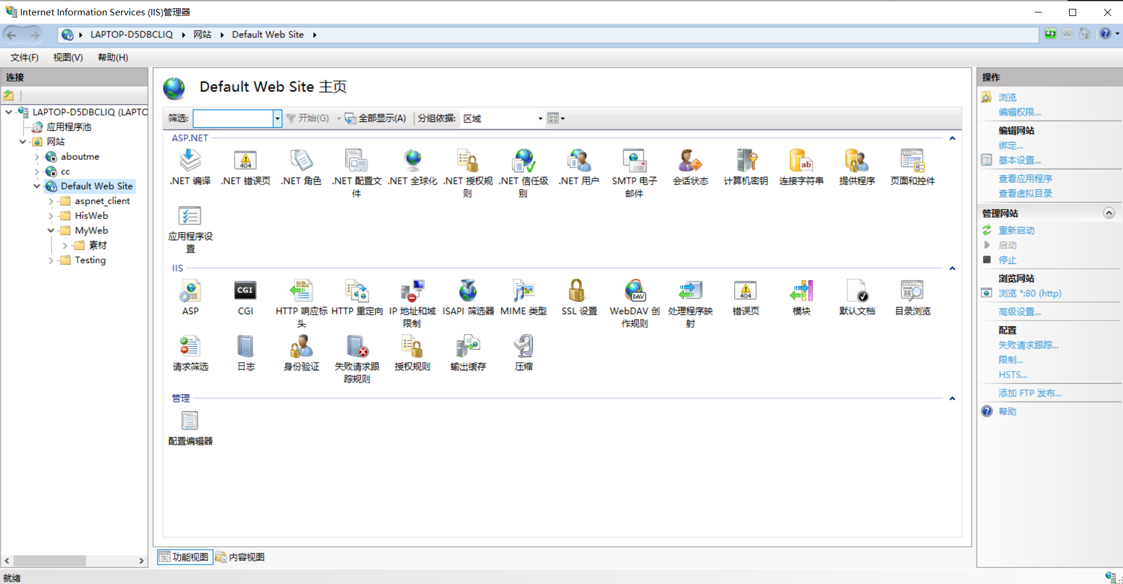

## 请贴出个人主页截图

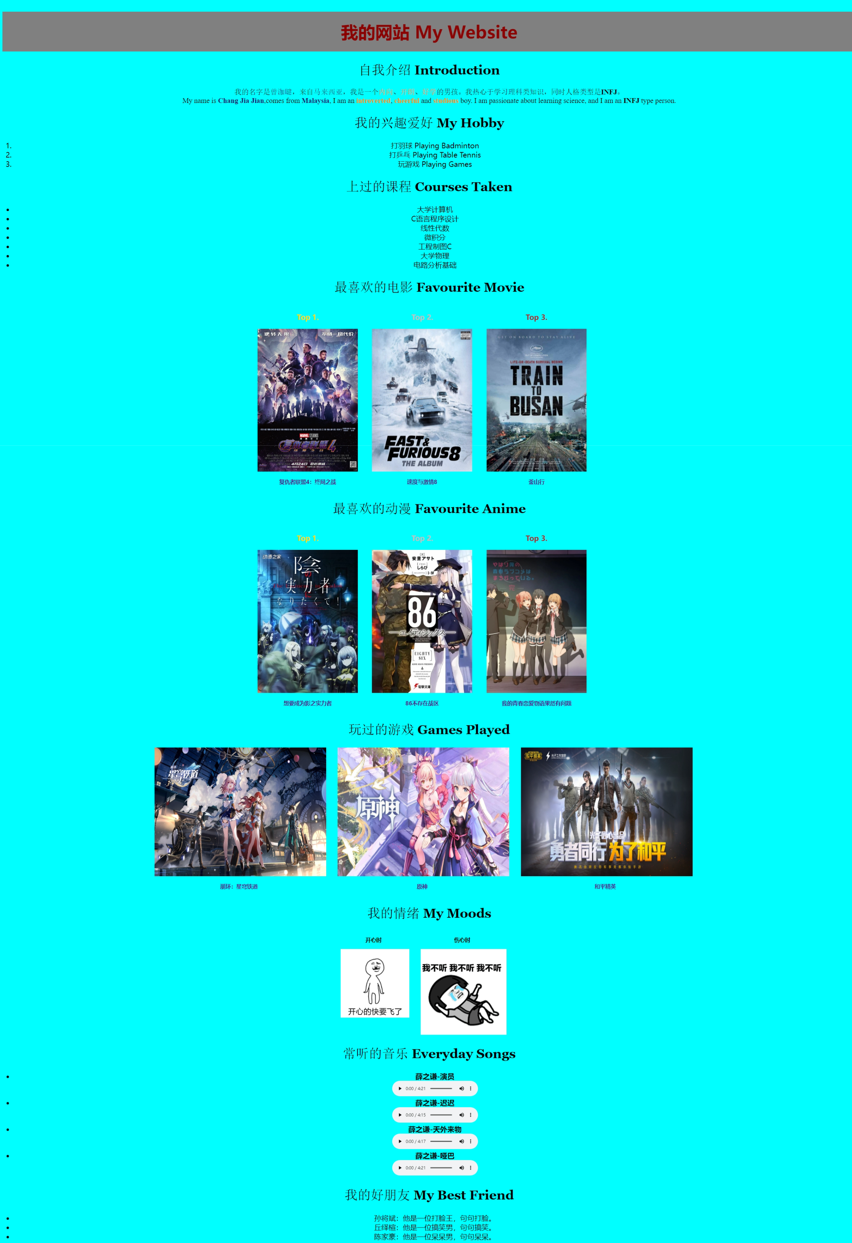

## 请贴出个人主页 HTML CSS 源代码

**HTML：**

<!DOCTYPE html>

<html lang="en">

<head>

<link rel="stylesheet" href="./aboutme-style.css">

<meta charset="UTF-8">

<meta name="viewport" content="width=device-width, initial-scale=1.0">

<title>AboutMe</title>

</head>

<body>

<h1>我的网站 My Website</h1>

<h2>自我介绍 Introduction</h2>

<p>

我的名字是<b class="a">曾泇睷</b>，来自<b class="a">马来西亚</b>，我是一个<b class="b">内向</b>、<b class="b">开朗</b>、<b class="b">好学</b>的男孩。我热心于学习理科类知识，同时人格类型是<b>INFJ</b>。<br>

My name is <b class="a">Chang Jia Jian</b>,comes from <b class="a">Malaysia</b>, I am an <b class="b">introverted</b>, <b class="b">cheerful</b> and <b class="b">studious</b> boy. I am passionate about learning science, and I am an <b>INFJ</b> type person.

</p>

<h2>我的兴趣爱好 My Hobby</h2>

<ol>

<li>打羽球 Playing Badminton</li>

<li>打乒乓 Playing Table Tennis</li>

<li>玩游戏 Playing Games</li>

</ol>

<h2>上过的课程 Courses Taken</h2>

<div class="center">

<ul>

<li>大学计算机</li>

<li>C语言程序设计</li>

<li>线性代数</li>

<li>微积分</li>

<li>工程制图C</li>

<li>大学物理</li>

<li>电路分析基础</li>

</ul>

</div>

<h2>最喜欢的电影 Favourite Movie</h2>

<div class="bolder">

<div class="favourite">

<h3 class="top1">Top 1.</h3>

<a href="https://www.imdb.com/title/tt4154796/?ref_=nv_sr_srsg_7_tt_8_nm_0_q_avenger" target="_blank">

<img class="tv" src="./素材/AvengerPic.png" alt="最喜欢的电影(Top1)" title="复仇者联盟4：终局之战">

</a>

<a class="name" href="https://www.imdb.com/title/tt4154796/?ref_=nv_sr_srsg_7_tt_8_nm_0_q_avenger" target="_blank">

<h3 class="name">复仇者联盟4：终局之战</h3>

</a>

</div>

<div class="favourite">

<h3 class="top2">Top 2.</h3>

<a href="https://www.imdb.com/title/tt4630562/?ref_=nv_sr_srsg_0_tt_8_nm_0_q_fast%2520and%2520furious%25208" target="_blank">

<img class="tv" src="./素材/速度与激情8.jpg" alt="最喜欢的电影(Top2)" title="速度与激情8">

</a>

<a class="name" href="https://www.imdb.com/title/tt4630562/?ref_=nv_sr_srsg_0_tt_8_nm_0_q_fast%2520and%2520furious%25208" target="_blank">

<h3 class="name">速度与激情8</h3>

</a>

</div>

<div class="favourite">

<h3 class="top3">Top 3.</h3>

<a href="https://www.imdb.com/title/tt5700672/?ref_=nv_sr_srsg_0_tt_8_nm_0_q_train%2520to" target="_blank">

<img class="tv" src="./素材/Train-to-Busan.jpg" alt="最喜欢的电影(Top3)" title="釜山行">

</a>

<a class="name" href="https://www.imdb.com/title/tt5700672/?ref_=nv_sr_srsg_0_tt_8_nm_0_q_train%2520to" target="_blank">

<h3 class="name">釜山行</h3>

</a>

</div>

</div>

<h2>最喜欢的动漫 Favourite Anime</h2>

<div class="bolder">

<div class="favourite">

<h3 class="top1">Top 1.</h3>

<a href="https://www.imdb.com/title/tt14115938/?ref_=nv_sr_srsg_0_tt_8_nm_0_q_%25E6%2583%25B3%25E8%25A6%2581" target="_blank">

<img class="tv" src="./素材/想要成为影之实力者.jpg" alt="最喜欢的动漫(Top1)" title="想要成为影之实力者">

</a>

<a class="name" href="https://www.imdb.com/title/tt14115938/?ref_=nv_sr_srsg_0_tt_8_nm_0_q_%25E6%2583%25B3%25E8%25A6%2581" target="_blank">

<h3 class="name">想要成为影之实力者</h3>

</a>

</div>

<div class="favourite">

<h3 class="top2">Top 2.</h3>

<a href="https://www.imdb.com/title/tt13718450/?ref_=nv_sr_srsg_0_tt_8_nm_0_q_86" target="_blank">

<img class="tv" src="./素材/86不存在战区.jpg" alt="最喜欢的动漫(Top2)" title="86不存在战区">

</a>

<a class="name" href="https://www.imdb.com/title/tt13718450/?ref_=nv_sr_srsg_0_tt_8_nm_0_q_86" target="_blank">

<h3 class="name">86不存在战区</h3>

</a>

</div>

<div class="favourite">

<h3 class="top3">Top 3.</h3>

<a href="https://www.imdb.com/title/tt2703720/?ref_=nv_sr_srsg_0_tt_8_nm_0_q_my%2520teen%2520roman" target="_blank">

<img class="tv" src="./素材/我的青春恋爱物语果然有问题.jpg" alt="最喜欢的动漫(Top3)" title="我的青春恋爱物语果然有问题">

</a>

<a class="name" href="https://www.imdb.com/title/tt2703720/?ref_=nv_sr_srsg_0_tt_8_nm_0_q_my%2520teen%2520roman" target="_blank">

<h3 class="name">我的青春恋爱物语果然有问题</h3>

</a>

</div>

</div>

<h2>玩过的游戏 Games Played</h2>

<div class="bolder">

<div class="favourite">

<a href="https://sr.mihoyo.com/?nav=home" target="_blank">

<img class="game" src="./素材/星穹铁道.jfif" alt="曾玩过的游戏" title="崩坏：星穹铁道（在玩）">

</a>

<a class="name" href="https://sr.mihoyo.com/?nav=home" target="_blank">

<h3 class="name">崩坏：星穹铁道</h3>

</a>

</div>

<div class="favourite">

<a href="https://ys.mihoyo.com/" target="_blank">

<img class="game" src="./素材/原神.jfif" alt="曾玩过的游戏" title="原神（已退游）">

</a>

<a class="name" href="https://ys.mihoyo.com/" target="_blank">

<h3 class="name">原神</h3>

</a>

</div>

<div class="favourite">

<a href="https://gp.qq.com/main.shtml" target="_blank">

<img class="game" src="./素材/和平精英.jpg" alt="曾玩过的游戏" title="和平精英（已退游）">

</a>

<a class="name" href="https://gp.qq.com/main.shtml" target="_blank">

<h3 class="name">和平精英</h3>

</a>

</div>

</div>

<h2>我的情绪 My Moods</h2>

<div class="bolder">

<div class="favourite">

<h3 class="mood">开心时</h3>

<img class="mood" src="./素材/开心.gif" alt="开心的样子">

</div>

<div class="favourite">

<h3 class="mood">伤心时</h3>

<img class="mood" src="./素材/伤心.gif" alt="开心的样子">

</div>

</div>

<h2>常听的音乐 Everyday Songs</h2>

<ul>

<li><b>薛之谦-演员</b></li>

<li class="music"><audio src="./素材/薛之谦-演员.mp3" controls></audio></li>

<li><b>薛之谦-迟迟</b></li>

<li class="music"><audio src="./素材/薛之谦-迟迟.mp3" controls></audio></li>

<li><b>薛之谦-天外来物</b></li>

<li class="music"><audio src="./素材/薛之谦-天外来物.mp3" controls></audio></li>

<li><b>薛之谦-哑巴</b></li>

<li class="music"><audio src="./素材/薛之谦-哑巴.mp3" controls></audio></li>

</ul>

<h2>我的好朋友 My Best Friend</h2>

<ul>

<li>

孙将斌：他是一位打脸王，句句打脸。

</li>

<li>

丘绎楦：他是一位搞笑男，句句搞笑。

</li>

<li>

陈家豪：他是一位呆呆男，句句呆呆。

</li>

</ul>

</body>

</html>

**CSS：**

*{

box-sizing: border-box;

}

body {

text-align: center;

background-size: 2500px;

background-color:cyan;

}

h1

{

color: rgb(141, 0, 0);

background-color: gray;

padding: 30px 0;

font-size: 60px;

text-align: center;

}

h2{

font-size: 45px;

font-family:Georgia, 'Times New Roman', Times, serif ;

}

h3.top1{

color: gold;

font-size: 25px;

display: block;

text-align: center;

margin-left: -50px;

}

h3.top2{

color: silver;

font-size: 25px;

display: block;

text-align: center;

margin-left: -50px;

}

h3.top3{

color: brown;

font-size: 25px;

display: block;

text-align: center;

margin-left: -50px;

}

h3.name{

text-align: center;

margin-left: -50px;

}

h3.mood{

text-align: center;

margin-left: -50px;

}

a.name{

text-decoration: none;

}

a.name:hover{

text-decoration: underline;

}

b.a{

color:midnightblue;

}

b.b{

color:darkorange;

}

p{

font-weight:50;

font-size: 25px;

font-family:'Times New Roman', Times, serif;

}

img.tv{

width: 350px;

height: 500px;

margin-right: 50px;

}

img.tv:hover{

transform: translateY(-10px);

}

img.tv:active{

transform: translateY(0px);

}

img.game{

width: 600px;

height: 450px;

margin-right: 40px;

}

img.game:hover{

transform: translateY(-10px);

}

img.game:active{

transform: translateY(0px);

}

img.mood{

margin-right: 40px;

}

div.bolder{

display:inline-flex;

}

div.favourite{

display: block;

}

ul{

font-size: 25px;

margin: 0 auto;

}

li.music{

list-style-type: none;

}

ol{

font-size: 25px;

}

## 请贴出 在线考试页面 初始截图

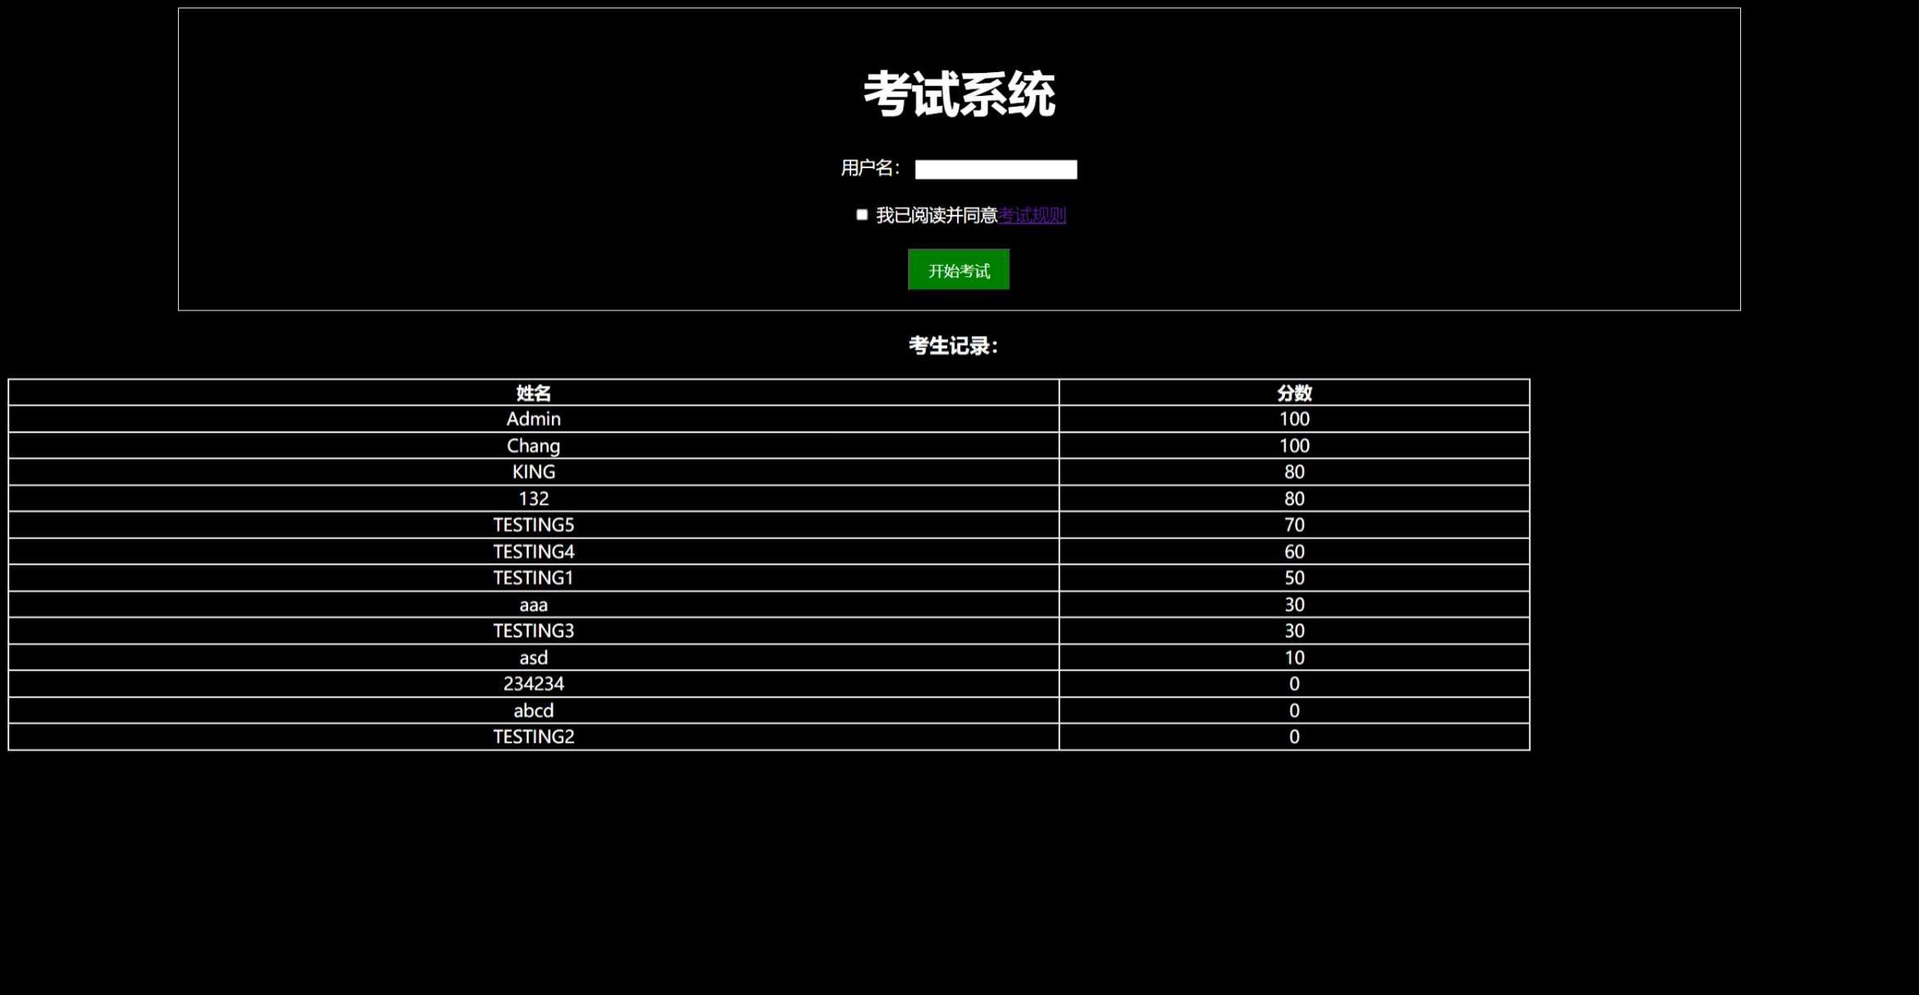

## 做一套非全对测试 贴出关键过程截图

提交成绩前

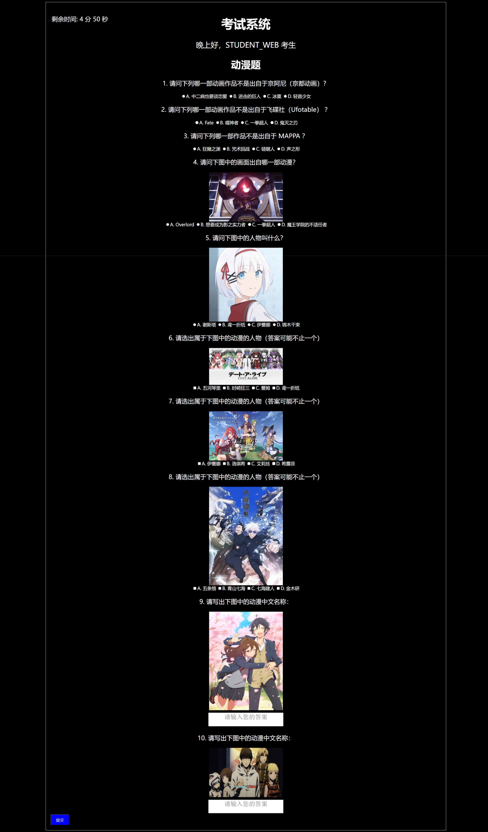

提交后弹出成绩对话框

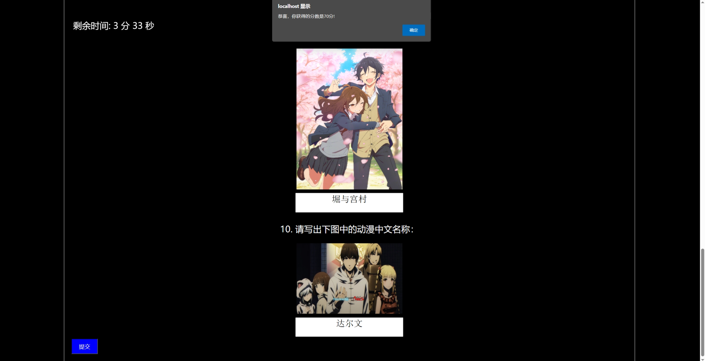

点击确定后

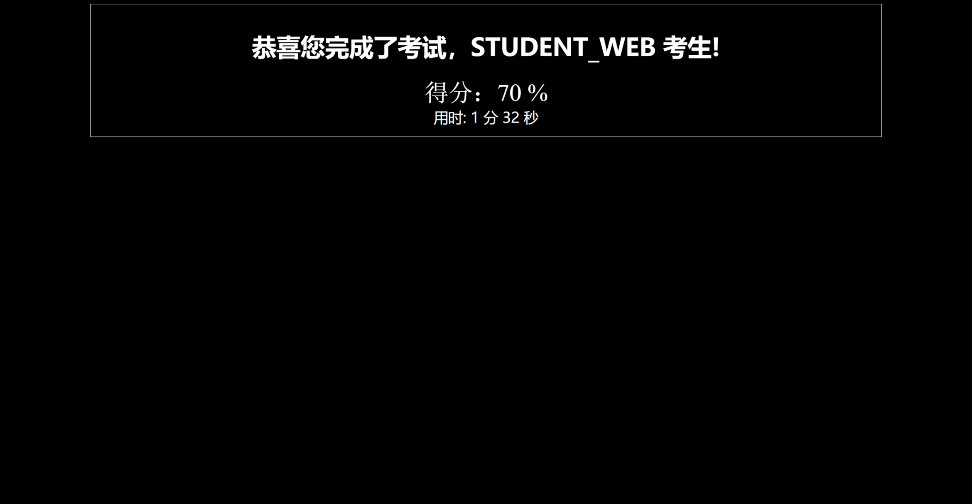

写入数据库后页面

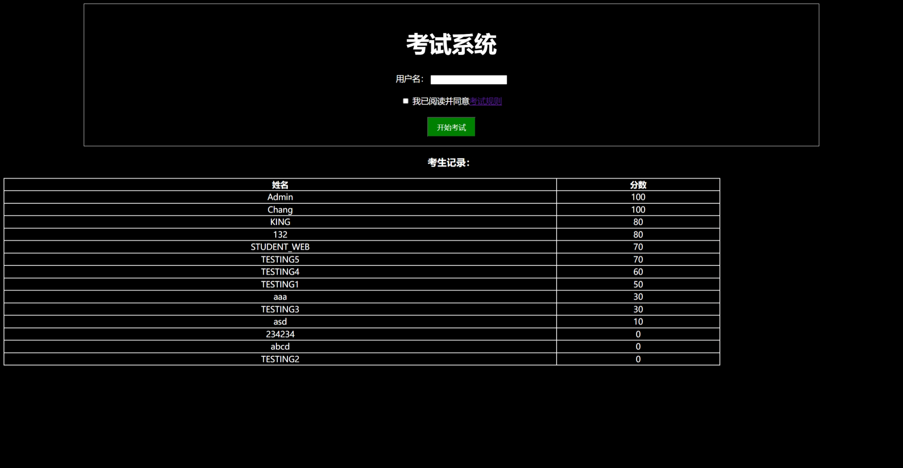

列出历史考试成绩页面



## 请贴出实验三（四）全部源代码

**主网页：**

<!DOCTYPE html>

<html>

<head>

<meta charset="UTF-8">

<meta name="viewport" content="width=device-width, initial-scale=1.0">

<title>考试系统</title>

<style>

body {

background-color: black;

color: white;

font-size: 18px;

text-align: center;

}

h1 {

font-size: 50px;

}

h2 {

font-size: 40px;

}

textarea {

resize: none;

width: 300px;

height: 50px;

font-size: 25px;

text-align: center;

margin-top: 10px;

}

table {

text-align: center;

border-collapse: collapse;

width: 80%;

border: 2px solid white;

}

th, td{

border: 2px solid white;

}

#timer {

height: 50px;

width: 450px;

font-size: 25px;

position: fixed;

top: 60px;

left: 100px;

}

#Hello {

font-size: 30px;

}

#examContainer {

margin: 0 auto;

width: 80%;

padding: 20px;

border: 1px solid white;

}

#endDisplay {

margin: 0 auto;

width: 80%;

padding: 20px;

border: 1px solid white;

}

#startButton {

background-color: green;

color: white;

padding: 10px 20px;

font-size: 16px;

cursor: pointer;

}

#submitButton {

background-color: blue;

color: white;

padding: 10px 20px;

font-size: 16px;

cursor: pointer;

}

#questionImg1 {

display: block;

width: 300px;

height: 200px;

margin: 0 auto;

}

#questionImg2 {

display: block;

width: 300px;

height: 300px;

margin: 0 auto;

}

#questionImg3 {

display: block;

width: 300px;

height: 150px;

margin: 0 auto;

}

#questionImg4 {

display: block;

width: 300px;

height: 200px;

margin: 0 auto;

}

#questionImg5 {

display: block;

width: 300px;

height: 400px;

margin: 0 auto;

}

#questionImg6 {

display: block;

width: 300px;

height: 400px;

margin: 0 auto;

}

#questionImg7 {

display: block;

width: 300px;

height: 200px;

margin: 0 auto;

}

#questionContainer p {

font-size: 25px;

}

#usedTime {

font-size: 30px;

}

#score {

font-size: 50px;

font-family: 'Times New Roman', Times, serif;

}

#incorrectAnswers {

font-size: 30px;

}

</style>

</head>

<body>

<script>

var userAnswers = {};

var incorrectAnswers = {};

var isSubmitted = false;

var timeStart;

var time;

var countdown = 300;

var minutes;

var seconds;

var score = 0;

var incorrectAmount = 0;

function displayHello() {

var username = document.getElementById("username").value;

var now = new Date();

var hours = now.getHours();

var hello = "";

if (hours >= 6 && hours < 12) {

hello = "早上好，" + username + " 考生";

}

else if (hours >= 12 && hours < 18) {

hello = "下午好，" + username + " 考生";

}

else{

hello = "晚上好，" + username + " 考生";

}

document.getElementById("Hello").innerHTML = hello;

}

function startTimer() {

timeStart = new Date();

time = setInterval(updateTimer, 1000);

displayTime();

}

function displayTime() {

var minutesRemaining = Math.floor(countdown / 60);

var secondsRemaining = countdown % 60;

document.getElementById("timer").innerHTML = "剩余时间: " + minutesRemaining + " 分 " + secondsRemaining + " 秒";

if (countdown === 0) {

endExam(); // 自动提交考试

} else {

countdown--; // 每秒减一

setTimeout(displayTime, 1000); // 每隔一秒更新显示

}

}

function updateTimer() {

var currentTime = new Date();

var timeDiff = currentTime - timeStart;

seconds = Math.floor(timeDiff / 1000);

minutes = Math.floor(seconds / 60);

seconds = seconds % 60;

}

function startExam() {

var username = document.getElementById("username").value;

var rule = document.getElementById("readRules").checked;

var blankCnt = 0;

for (let i = 0; i < username.length; i++) {

if (username[i] == ' ') {

blankCnt++;

}

}

if (blankCnt == username.length && username) {

alert("请不要输入空白名！");

}

else if (rule && username) {

document.getElementById("startDisplay").style.display = "none";

document.getElementById("startDisplay2").style.display = "none";

document.getElementById("timer").style.display = "block";

document.getElementById("questionContainer").style.display = "block";

document.getElementById("submitButton").style.display = "block";

displayHello();

startTimer();

}

else if (username) {

alert("请阅读并同意考试规则才可开始考试！");

}

else if (rule) {

alert("请填写用户名再开始考试！");

}

else {

alert("请填写用户名并阅读同意考试规则才可开始考试！");

}

}

function endExam() {

var username = document.getElementById("username").value;

document.getElementById("examContainer").style.display = "none";

calculateScore();

var xhr = new XMLHttpRequest();

xhr.open("POST", "process_form.asp", true);

xhr.setRequestHeader("Content-Type", "application/x-www-form-urlencoded");

xhr.send("username=" + encodeURIComponent(username) + "&score=" + score);

document.getElementById("endDisplay").style.display = "block";

document.getElementById("user").innerHTML = "恭喜您完成了考试，" + username + " 考生!";

document.getElementById("usedTime").innerHTML = "用时: " + minutes + " 分 " + seconds + " 秒";

document.getElementById("score").innerHTML = "得分：" + score + " %";

document.getElementById("startDisplay2").style.display = "block";

if (score > 50){

alert("恭喜，你获得的分数是" + score + "分!");

}

else{

alert("很遗憾，你只获得了"+ score + "分，再接再厉...")

}

}

function calculateScore() {

var isCorrect = 1;

var correctAnswer = [

{

answer: "B"

},

{

answer: "C"

},

{

answer: "D"

},

{

answer: "B"

},

{

answer: "A"

},

{

answer: ["A", "B", "D"]

},

{

answer: ["B", "C", "D"]

},

{

answer: ["A", "C"]

},

{

answer: "堀与宫村"

},

{

answer: "达尔文游戏"

}

]

for (let i = 1; i < 6; i++) {

userAnswers = document.getElementsByName("q" + i);

for (let j = 0; j < 4; j++) {

if (userAnswers[j].checked) {

if (userAnswers[j].value == correctAnswer[i - 1].answer[0]) {

score++;

}

else {

incorrectAnswers[incorrectAmount++] = document.getElementById("Question" + i);

}

}

}

}

for (let i = 6; i < 9; i++) {

var cnt = 0, pre = 0;

isCorrect = 1;

userAnswers = document.getElementsByName("q" + i);

for (let j = 0; j < 4; j++) {

pre = cnt;

if (userAnswers[j].checked) {

for (let k = 0; k < correctAnswer[i - 1].answer.length; k++) {

if (userAnswers[j].value == correctAnswer[i - 1].answer[k]) {

cnt++;

}

}

if (pre == cnt) {

isCorrect = 0;

}

}

}

if (cnt == correctAnswer[i - 1].answer.length && isCorrect) {

score++;

}

}

for (let i = 9; i < 11; i++) {

var cnt = 0;

var cntBlank = 0;

userAnswers = document.getElementById("q" + i).value;

for (let j = 0; j < correctAnswer[i - 1].answer.length; j++) {

if (userAnswers[j] == correctAnswer[i - 1].answer[j]) {

cnt++;

}

}

if (cnt == correctAnswer[i - 1].answer.length && userAnswers.length - cntBlank == correctAnswer[i - 1].answer.length) {

score++;

}

}

score *= 10;

}

</script>

<div id="examContainer">

<h1>考试系统</h1>

<div id="startDisplay">

<label for="username">用户名：</label>

<input type="text" id="username" name="username" required><br><br>

<input type="checkbox" id="readRules" required>

<label for="readRules">我已阅读并同意<a href="./ExamRules.html" target="_blank">考试规则</a></label><br><br>

<button type="button" id="startButton" onclick="startExam()">开始考试</button>

</div>

<div id="Hello"></div>

<div id="timer" style="display: none;"></div>

<div id="questionContainer" style="display: none;">

<h2>动漫题</h2>

<div id="question1">

<p id="Question1">1. 请问下列哪一部动画作品不是出自于京阿尼（京都动画）？</p>

<label><input type="radio" name="q1" value="A">A. 中二病也要谈恋爱</label>

<label><input type="radio" name="q1" value="B">B. 进击的巨人</label>

<label><input type="radio" name="q1" value="C">C. 冰菓</label>

<label><input type="radio" name="q1" value="D">D. 轻音少女</label>

</div>

<div id="question2">

<p id="Question2">2. 请问下列哪一部动画作品不是出自于飞碟社（Ufotable） ？</p>

<label><input type="radio" name="q2" value="A">A. Fate</label>

<label><input type="radio" name="q2" value="B">B. 噬神者</label>

<label><input type="radio" name="q2" value="C">C. 一拳超人</label>

<label><input type="radio" name="q2" value="D">D. 鬼灭之刃</label>

</div>

<div id="question3">

<p id="Question3">3. 请问下列哪一部作品不是出自于 MAPPA ？</p>

<label><input type="radio" name="q3" value="A">A. 狂赌之渊</label>

<label><input type="radio" name="q3" value="B">B. 咒术回战</label>

<label><input type="radio" name="q3" value="C">C. 链锯人</label>

<label><input type="radio" name="q3" value="D">D. 声之形</label>

</div>

<div id="question4">

<p id="Question4">4. 请问下图中的画面出自哪一部动漫？</p>

<img id="questionImg1" src="./素材/动漫1.jfif" alt="图1">

<label><input type="radio" name="q4" value="A">A. Overlord</label>

<label><input type="radio" name="q4" value="B">B. 想要成为影之实力者</label>

<label><input type="radio" name="q4" value="C">C. 一拳超人</label>

<label><input type="radio" name="q4" value="D">D. 魔王学院的不适任者</label>

</div>

<div id="question5">

<p id="Question5">5. 请问下图中的人物叫什么？</p>

<img id="questionImg2" src="./素材/人物1.jpg" alt="图2">

<label><input type="radio" name="q5" value="A">A. 谢斯塔</label>

<label><input type="radio" name="q5" value="B">B. 鸢一折纸</label>

<label><input type="radio" name="q5" value="C">C. 伊蕾娜</label>

<label><input type="radio" name="q5" value="D">D. 锦木千束</label>

</div>

<div id="question6">

<p id="Question6">6. 请选出属于下图中的动漫的人物（答案可能不止一个）</p>

<img id="questionImg3" src="./素材/动漫2.jfif" alt="图3">

<label><input type="checkbox" name="q6" value="A">A. 五河琴里</label>

<label><input type="checkbox" name="q6" value="B">B. 时崎狂三</label>

<label><input type="checkbox" name="q6" value="C">C. 蕾姆</label>

<label><input type="checkbox" name="q6" value="D">D. 鸢一折纸</label>

</div>

<div id="question7">

<p id="Question7">7. 请选出属于下图中的动漫的人物（答案可能不止一个）</p>

<img id="questionImg4" src="./素材/动漫3.jpg" alt="图4">

<label><input type="checkbox" name="q7" value="A">A. 伊蕾娜</label>

<label><input type="checkbox" name="q7" value="B">B. 洛琪希</label>

<label><input type="checkbox" name="q7" value="C">C. 艾莉丝</label>

<label><input type="checkbox" name="q7" value="D">D. 希露菲</label>

</div>

<div id="question8">

<p id="Question8">8. 请选出属于下图中的动漫的人物（答案可能不止一个）</p>

<img id="questionImg5" src="./素材/动漫4.jfif" alt="图5">

<label><input type="checkbox" name="q8" value="A">A. 五条悟</label>

<label><input type="checkbox" name="q8" value="B">B. 青山七海</label>

<label><input type="checkbox" name="q8" value="C">C. 七海建人</label>

<label><input type="checkbox" name="q8" value="D">D. 金木研</label>

</div>

<div id="question9">

<p id="Question9">9. 请写出下图中的动漫中文名称：</p>

<img id="questionImg6" src="./素材/动漫5.jpg" alt="图6">

<textarea id="q9" placeholder="请输入您的答案"></textarea>

</div>

<div id="question10">

<p id="Question10">10. 请写出下图中的动漫中文名称：</p>

<img id="questionImg7" src="./素材/动漫6.png" alt="图7">

<textarea id="q10" placeholder="请输入您的答案"></textarea>

</div>

</div>

<button id="submitButton" onclick="endExam()" style="display: none;">提交</button>

</div>

<div id="startDisplay2">

<h3>考生记录：</h3>

<table>

<tr>

<th>姓名</th>

<th>分数</th>

</tr>

<%

Set conn = Server.CreateObject("ADODB.Connection")

conn.Open "Provider=Microsoft.Jet.OLEDB.4.0;Data Source=C:\inetpub\wwwroot\MyWeb\score.mdb"

Set rs = conn.Execute("SELECT s_name,s_score FROM score ORDER BY s_score DESC")

While Not rs.EOF

%>

<tr>

<td><%=rs("s_name")%></td>

<td><%=rs("s_score")%></td>

</tr>

<%

rs.MoveNext

Wend

rs.Close

Set rs = Nothing

%>

</table>

</div>

<div id="endDisplay" style="display: none;">

<h1><div id="user"></div></h1>

<div id="score"></div>

<div id="usedTime"></div>

</div>

</body>

</html>

**考试规则网页：**

<!DOCTYPE html>

<html lang="en">

<head>

<meta charset="UTF-8">

<meta name="viewport" content="width=device-width, initial-scale=1.0">

<title>考试规则</title>

</head>

<body style="background-color:aqua;">

<h1 style="font-size: 50px; text-align: center;">考试规则 Exam Rules</h1>

<ul style="list-style: none; font-size: 30px; margin-left: 30%;">

<li>1. 考生必须填写正确的用户名，否则成绩无效。</li>

<li>2. 考试期间，考生不得浏览其它网页。</li>

<li>3. 考试期间，考生需要开启摄像头。</li>

<li>4. 考试期间，考生不允许离开电脑前。</li>

<li>5. 考生必须独立完成试卷，不允许抄袭。</li>

<li>6. 答题完毕后，点击提交即可得知考试成绩。</li>

</ul>

<p style="position: absolute; bottom: 50px; right: 40%;">

如有任何疑问，请联系考试主办方（微信：xChang1021x）。

</p>

</body>

</html>

**处理表单ASP（process_form.asp）：**

<%

Dim username

Dim score

username = Request.Form("username")

score = Request.Form("score")

Dim conn

Set conn = Server.CreateObject("ADODB.Connection")

conn.Open "Provider=Microsoft.Jet.OLEDB.4.0;Data Source=C:\inetpub\wwwroot\MyWeb\score.mdb"

Dim insertSQL

insertSQL = "INSERT INTO score (s_name, s_score) VALUES ('" & username & "', " & score & ")"

conn.Execute insertSQL

conn.Close

Set conn = Nothing

Response.Redirect ""

%>

## 实验中你觉得最困难的一点是什么，你是如何解决的？

我认为实验中最困难的是连接数据库和写入的问题，我通过网上查找相应的资料，不断在我的代码中调试，一步一步排查问题，然后慢慢地就解决了主要的问题。

## 你对实验中自己觉得最满意的一点是什么？为什么？

我觉得对实验最满意的一点还是考试题目和网页的判断逻辑的部分，因为考试题目都是自己出的题，并且通过网上资料查询答案的准确性。网页的判断方面，实现了用户名必须填写并且当填上空白字符时会不让他通过，实现了倒计时结束自动提交，答案的判断逻辑也符合正常考试的情形，多选题只有在都选上才会判断正确。所以我对这里的部分还算是最满意的。

## 你觉得自己做的网站将来还有哪些提高完善的地方

我觉得我的网站在将来还可以有美化的地方，让网站的视觉效果更好的体现给用户。除此之外，我认为将来还可以让用户注册账户再进行考试，将他的用户名密码写入数据库，实现登录才能考试，此外还可以用数据库记录考生更多的信息（如 用时 错题等等）。总而言之，我的网站还有很多的地方可以改善，并提高完善性。